Amortecedores
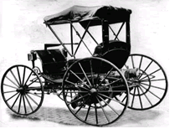
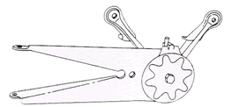
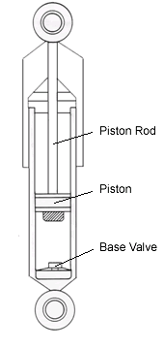
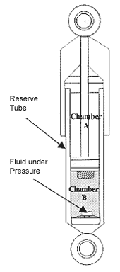
In the early 1900's, cars still rode on carriage springs. After all, early drivers had bigger things to worry about than the quality of their ride - like keeping their cars rolling over the rocks and ruts that often passed for roads.
Pioneering vehicle manufacturers were faced early on with the challenges of enhancing driver control and passenger comfort. These early suspension designs found the front wheels attached to the axle using steering spindles and kingpins. This allowed the wheels to pivot while the axle remained stationary. Additionally, the up and down oscillation of the leaf spring was damped by device called a shock absorber.
These first shock absorbers were simply two arms connected by a bolt with a friction disk between them. Resistance was adjusted by tightening or loosening the bolt.
As might be expected, the shocks were not very durable, and the performance left much to be desired. Over the years, shock absorbers have evolved into more sophisticated designs.
WHAT SHOCKS DO
Let's start our discussion of shock absorbers with one of very important point: despite what many people think, conventional shock absorbers do not support vehicle weight. Instead, the primary purpose of the shock absorber is to control spring and suspension movement. This is accomplished by turning the kinetic energy of suspension movement into thermal energy, or heat energy, to be dissipated through the hydraulic fluid.
Shock absorbers are basically oil pumps. A piston is attached to the end of the piston rod and works against hydraulic fluid in the pressure tube. As the suspension travels up and down, the hydraulic fluid is forced through tiny holes, called orifices, inside the piston. However, these orifices let only a small amount of fluid through the piston. This slows down the piston, which in turn slows down spring and suspension movement.
The amount of resistance a shock absorber develops depends on the speed of the suspension and the number and size of the orifices in the piston. All modern shock absorbers are velocity sensitive hydraulic damping devices - meaning the faster the suspension moves, the more resistance the shock absorber provides. Because of this feature, shock absorbers adjust to road conditions. As a result, shock absorbers reduce the rate of:
- Bounce
- Roll or sway
- Brake dive and Acceleration squat
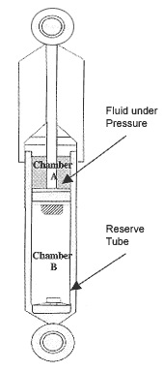
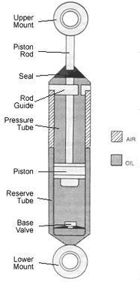
Shock absorbers work on the principle of fluid displacement on both the compression and extension cycle. A typical car or light truck will have more resistance during its extension cycle then its compression cycle. The compression cycle controls the motion of a vehicle's unsprung weight, while extension controls the heavier sprung weight.
Compression cycle
During the compression stroke or downward movement, some fluid flows through the piston from chamber B to chamber A and some through the compression valve into the reserve tube. To control the flow, there are three valving stages each in the piston and in the compression valve.
At the piston, oil flows through the oil ports, and at slow piston speeds, the first stage bleeds come into play and restrict the amount of oil flow. This allows a controlled flow of fluid from chamber B to chamber A.
At faster piston speeds, the increase in fluid pressure below the piston in chamber B causes the discs to open up away from the valve seat.
At high speeds, the limit of the second stage discs phases into the third stage orifice restrictions. Compression control, then, is the force that results from a higher pressure present in chamber B, which acts on the bottom of the piston and the piston rod area.
Extension cycle
As the piston and rod move upward toward the top of the pressure tube, the volume of chamber A is reduced and thus is at a higher pressure than chamber B. Because of this higher pressure, fluid flows down through the piston's 3-stage extension valve into chamber B.
However, the piston rod volume has been withdrawn from chamber B greatly increasing its volume. Thus the volume of fluid from chamber A is insufficient to fill chamber B. The pressure in the reserve tube is now greater than that in chamber B, forcing the compression intake valve to unseat. Fluid then flows from the reserve tube into chamber B, keeping the pressure tube full.
Extension control is a force present as a result of the higher pressure in chamber A, acting on the topside of the piston area.
SHOCK ABSORBER DESIGN
There are several shock absorber designs in use today:
- Twin Tube Designs
  - Gas Charged
  - PSD
  - ASD
Mono-Tube
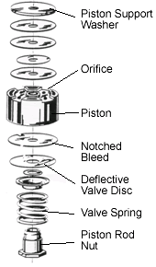
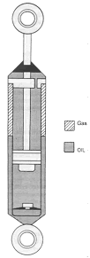
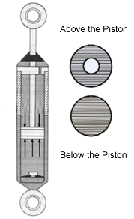
Basic Twin Tube Design
The twin tube design has an inner tube known as the working or pressure tube and an outer tube known as the reserve tube. The outer tube is used to store excess hydraulic fluid.
There are many types of shock absorber mounts used today. Most of these use rubber bushings between the shock absorber and the frame or suspension to reduce transmitted road noise and suspension vibration. The rubber bushings are flexible to allow movement during suspension travel. The upper mount of the shock absorber connects to the vehicle frame.
Notice that the piston rod passes through a rod guide and a seal at the upper end of the pressure tube. The rod guide keeps the rod in line with the pressure tube and allows the piston to move freely inside. The seal keeps the hydraulic oil inside and contamination out.
The base valve located at the bottom of the pressure tube is called a compression valve. It controls fluid movement during the compression cycle.
Bore size is the diameter of the piston and the inside of the pressure tube. Generally, the larger the unit, the higher the potential control levels because of the larger piston displacement and pressure areas. The larger the piston area, the lower the internal operating pressure and temperatures. This provides higher damping capabilities.
Ride engineers select valving values for a particular vehicle to achieve optimal ride characteristics of balance and stability under a wide variety of driving conditions. Their selection of valve springs and orifices control fluid flow within the unit, which determines the feel and handling of the vehicle.
Twin Tube - Gas Charged Design
The development of gas charged shock absorbers was a major advance in ride control technology. This advance solved many ride control problems which occurred due to an increasing number of vehicles using uni-body construction, shorter wheelbases and increased use of higher tire pressures.
The design of twin tube gas charged shock absorbers solves many of today's ride control problems by adding a low pressure charge of nitrogen gas in the reserve tube. The pressure of the nitrogen in the reserve tube varies from 100 to 150 psi, depending on the amount of fluid in the reserve tube. The gas serves several important functions to improve the ride control characteristics of a shock.
The prime function of gas charging is to minimize aeration of the hydraulic fluid. The pressure of the nitrogen gas compresses air bubbles in the hydraulic fluid. This prevents the oil and air from mixing and creating foam. Foam affects performance because it can be compressed - fluid can not. With aeration reduced, the shock is able to react faster and more predictably, allowing for quicker response time and helping keep the tire firmly planted on the road surface.
An additional benefit of gas charging is that it creates a mild boost in spring rate to the vehicle. This does not mean that a gas charged shock would raise the vehicle up to correct ride height if the springs were sagging. It does help reduce body roll, sway, brake dive, and acceleration squat.
This mild boost in spring rate is also caused by the difference in the surface area above and below the piston. With greater surface area below the piston than above, more pressurized fluid is in contact with this surface. This is why a gas charged shock absorber will extend on its own.
The final important function of the gas charge is to allow engineers greater flexibility in valving design. In the past such factors as damping and aeration forced compromises in design.
Advantages:
- Improves handling by reducing roll, sway and dive
- Reduces aeration offering a greater range of control over a wider variety of road conditions as compared to non-gas units
Reduced fade - shocks can lose damping capability as they heat up during use. Gas charged shocks could cut this loss of performance, called fade
Disadvantages:
Can only be mounted in one direction
Current Uses:
- Original equipment on many domestic passenger car, SUV and light truck applications
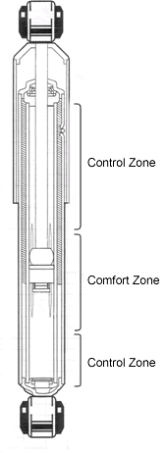
Twin Tube - PSD Design
In our earlier discussion of hydraulic shock absorbers we discussed that in the past, ride engineers had to compromise between soft valving and firm valving. With soft valving, the fluid flows more easily. The result is a smoother ride, but with poor handling and a lot of roll/sway. When valving is firm, fluid flows less easily. Handling is improved, but the ride can become harsh.
With the advent of gas charging, ride engineers were able to open up the orifice controls of these valves and improve the balance between comfort and control capabilities available in traditional velocity sensitive dampers.
A leap beyond fluid velocity control is an advanced technology that takes into account the position of the valve within the pressure tube. This is called Position Sensitive Damping (PSD).
The key to this innovation is precision tapered grooves in the pressure tube. Every application is individually tuned, tailoring the length, depth, and taper of these grooves to ensure optimal ride comfort and added control. This in essence creates two zones within the pressure tube.
The first zone, the comfort zone, is where normal driving takes place. In this zone the piston travel remains within the limits of the pressure tube's mid range. The tapered grooves allow hydraulic fluid to pass freely around and through the piston during its midrange travel. This action reduces resistance on the piston, assuring a smooth, comfortable ride.
The second zone, the control zone, is utilized during demanding driving situations. In this zone the piston travels out of the mid range area of the pressure tube and beyond the grooves. The entire fluid flow is directed through the piston valving for more control of the vehicle's suspension. The result is improved vehicle handling and better control without sacrificing ride comfort.
Advantages:
- Allows ride engineers to move beyond simple velocity sensitive valving and use the position of the piston to fine tune the ride characteristic.
- Adjusts more rapidly to changing road and weight conditions than standard shock absorbers
- Two shocks into one - comfort and control
Disadvantages:
- If vehicle ride height is not within manufacturer's specified range, piston travel may be limited to the control zone
Current Uses:
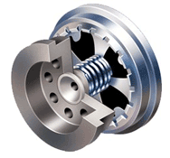
- Primarily aftermarket under the Sensa-Trac brand name
Twin Tube -ASD Design
We have discussed the compromises made by ride engineers to bring comfort and control together into one shock absorber. This compromise has been significantly reduced by the advent of gas charging and position sensitive damping technology.
A new twist on the comfort/ control compromise is an innovative technology which provides greater control for handling while improving ride comfort called Acceleration Sensitive Damping (ASD).
This technology moves beyond traditional velocity sensitive damping to focus and address impact. This focus on impact is achieved by utilizing a new compression valve design. This compression valve is a mechanical closed loop system, which opens a bypass to fluid flow around the compression valve.
This new application specific design allows minute changes inside the pressure tube based on inputs received from the road. The compression valve will sense a bump in the road and automatically adjust the shock to absorb the impact, leaving the shock with greater control when it is needed.
Due to the nearly instantaneous adjustment to changes in the road's condition, vehicle weight transfer is better managed during braking and turning. This technology enhances driver control by reducing pitch during braking and roll during turns.
Advantages:
- Control is enhanced without sacrificing driver comfort
- Valve automatically adjusts to changes in the road condition
- Reduces ride harshness
Disadvantages:
- Limited availability
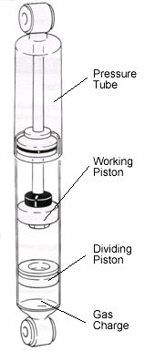
Current Uses:
- Primarily aftermarket applications under the Reflex brand name.
Mono-tube design
These are high-pressure gas shocks with only one tube, the pressure tube. Inside the pressure tube there are two pistons: a dividing piston and a working piston. The working piston and rod are very similar to the twin tube shock design. The difference in actual application is that a mono-tube shock absorber can be mounted upside down or right side up and will work either way. In addition to its mounting flexibility, mono-tube shocks are a significant component, along with the spring, in supporting vehicle weight.
Another difference you may notice is that the mono-tube shock absorber does not have a base valve. Instead, all of the control during compression and extension takes place at the piston.
The pressure tube of the mono-tube design is larger than a twin tube design to accommodate for dead length. This however makes it difficult to apply this design to passenger cars designed OE with a twin tube design. A free-floating dividing piston travels in the lower end of the pressure tube, separating the gas charge and the oil.
The area below the dividing piston is pressurized to about 360 psi with nitrogen gas. This high gas pressure helps support some of the vehicle's weight. The oil is located in the area above the dividing piston.
During operation, the dividing piston moves up and down as the piston rod moves in and out of the shock absorber, keeping the pressure tube full all times.
Advantages:
- Can be mounted upside down, reducing the unsprung weight
- May run cooler since the working tube is exposed to the air
Disadvantages:
- Difficult to apply to passenger cars designed OE with twin tube designs.
- A dent in the pressure tube will destroy the unit
Current Uses:
- Original equipment many import and performance domestic passenger cars, SUV and light truck applications
- Available for many Aftermarket applications
Fonte www.monroe.com

